User Story - Login

**Description**:

EventPlanner will require a login page even before you access any of the events/info. To sign up for EventPlanner you can either login with Facebook/Google or create your own user/pass through our own site. To define what happens when everything goes wrong, we’ll include a forget password or forgot username button. The nice aspect of using 3rd party authentication is that they already have this done. The main purpose in this is making sure we have user information, so we can keep track of what events they are interested in or want to sign up for. We’re including 4 different designs for logins and each captures a unique aspect of how one could log into our site.

Design 1)

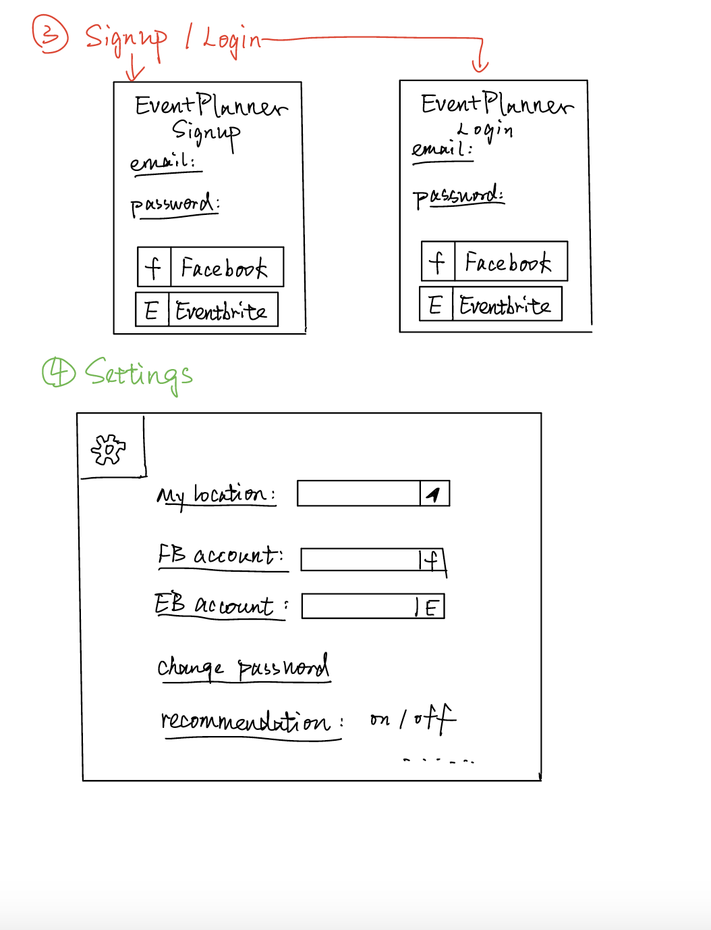

Design 2)

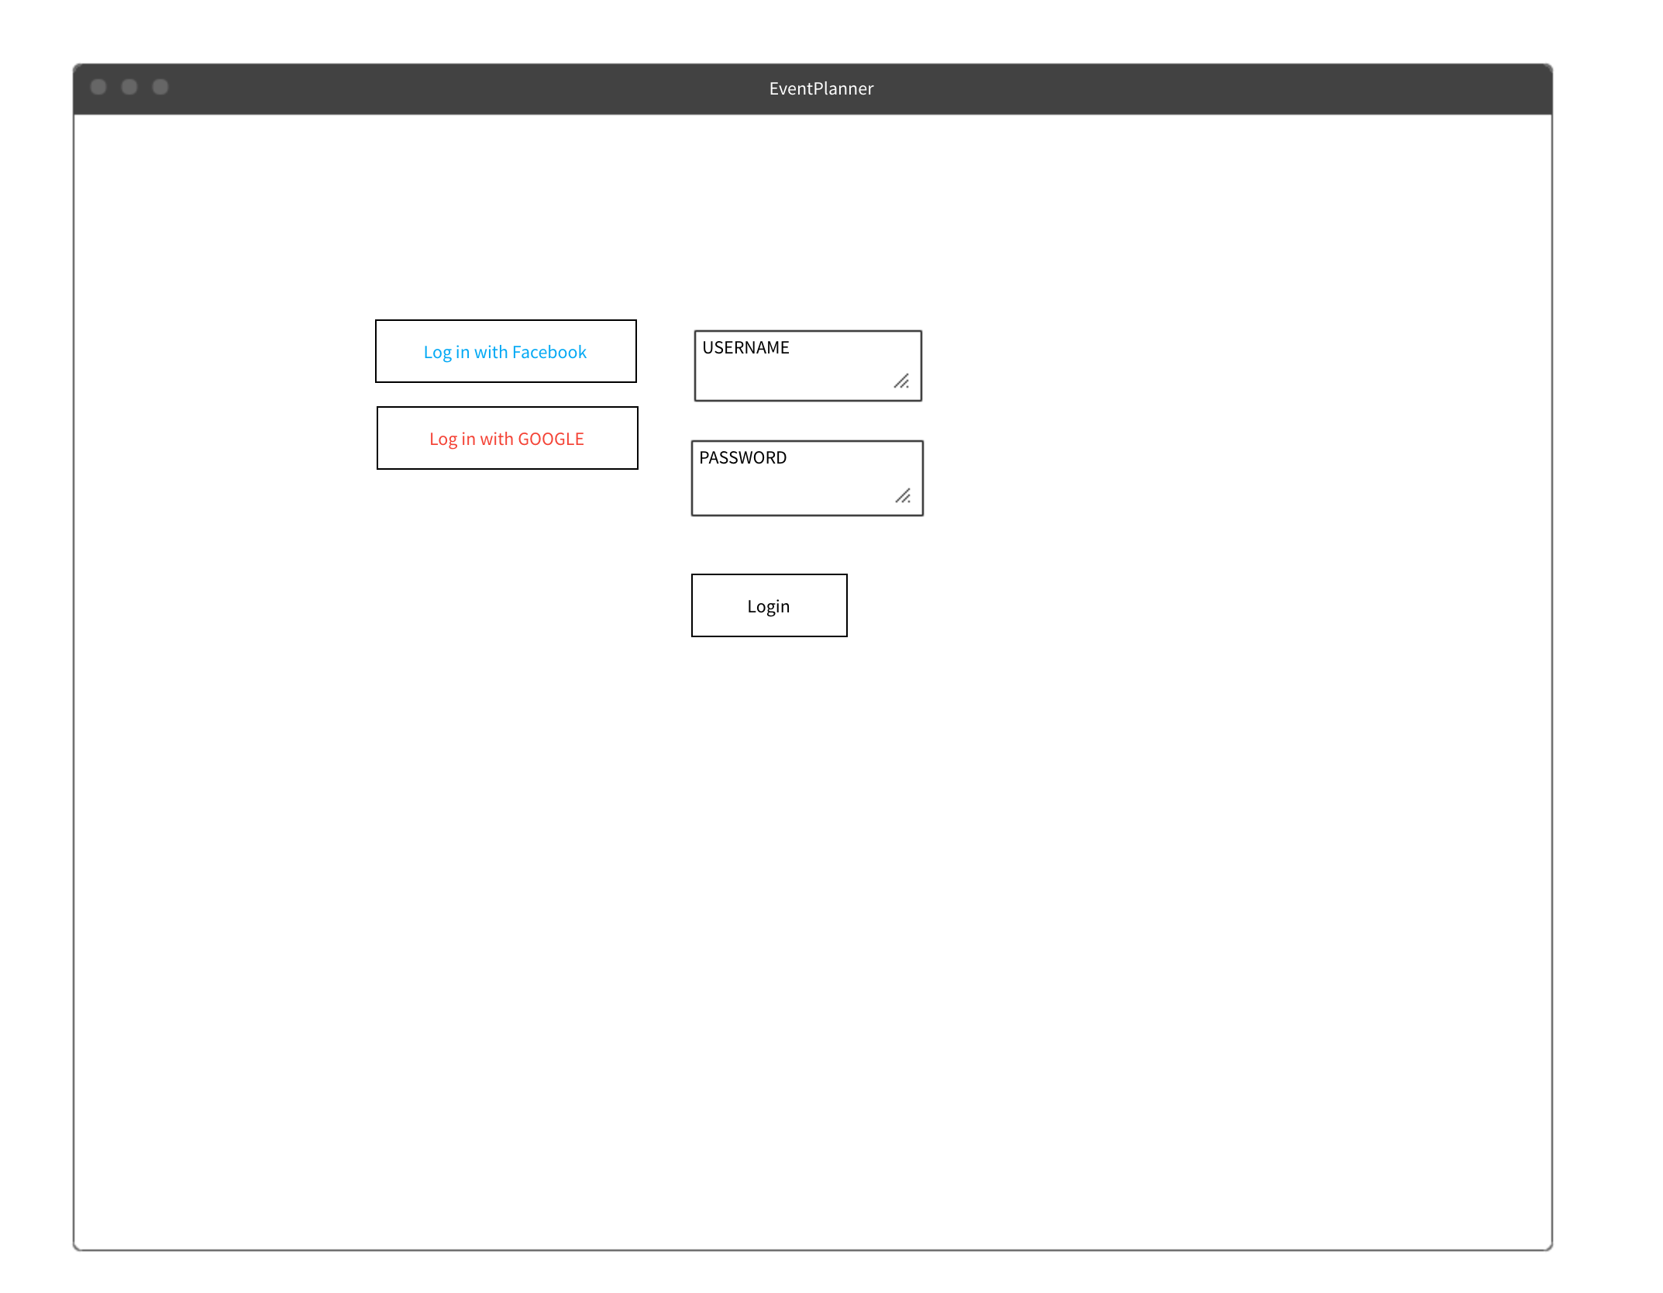

Design 3)

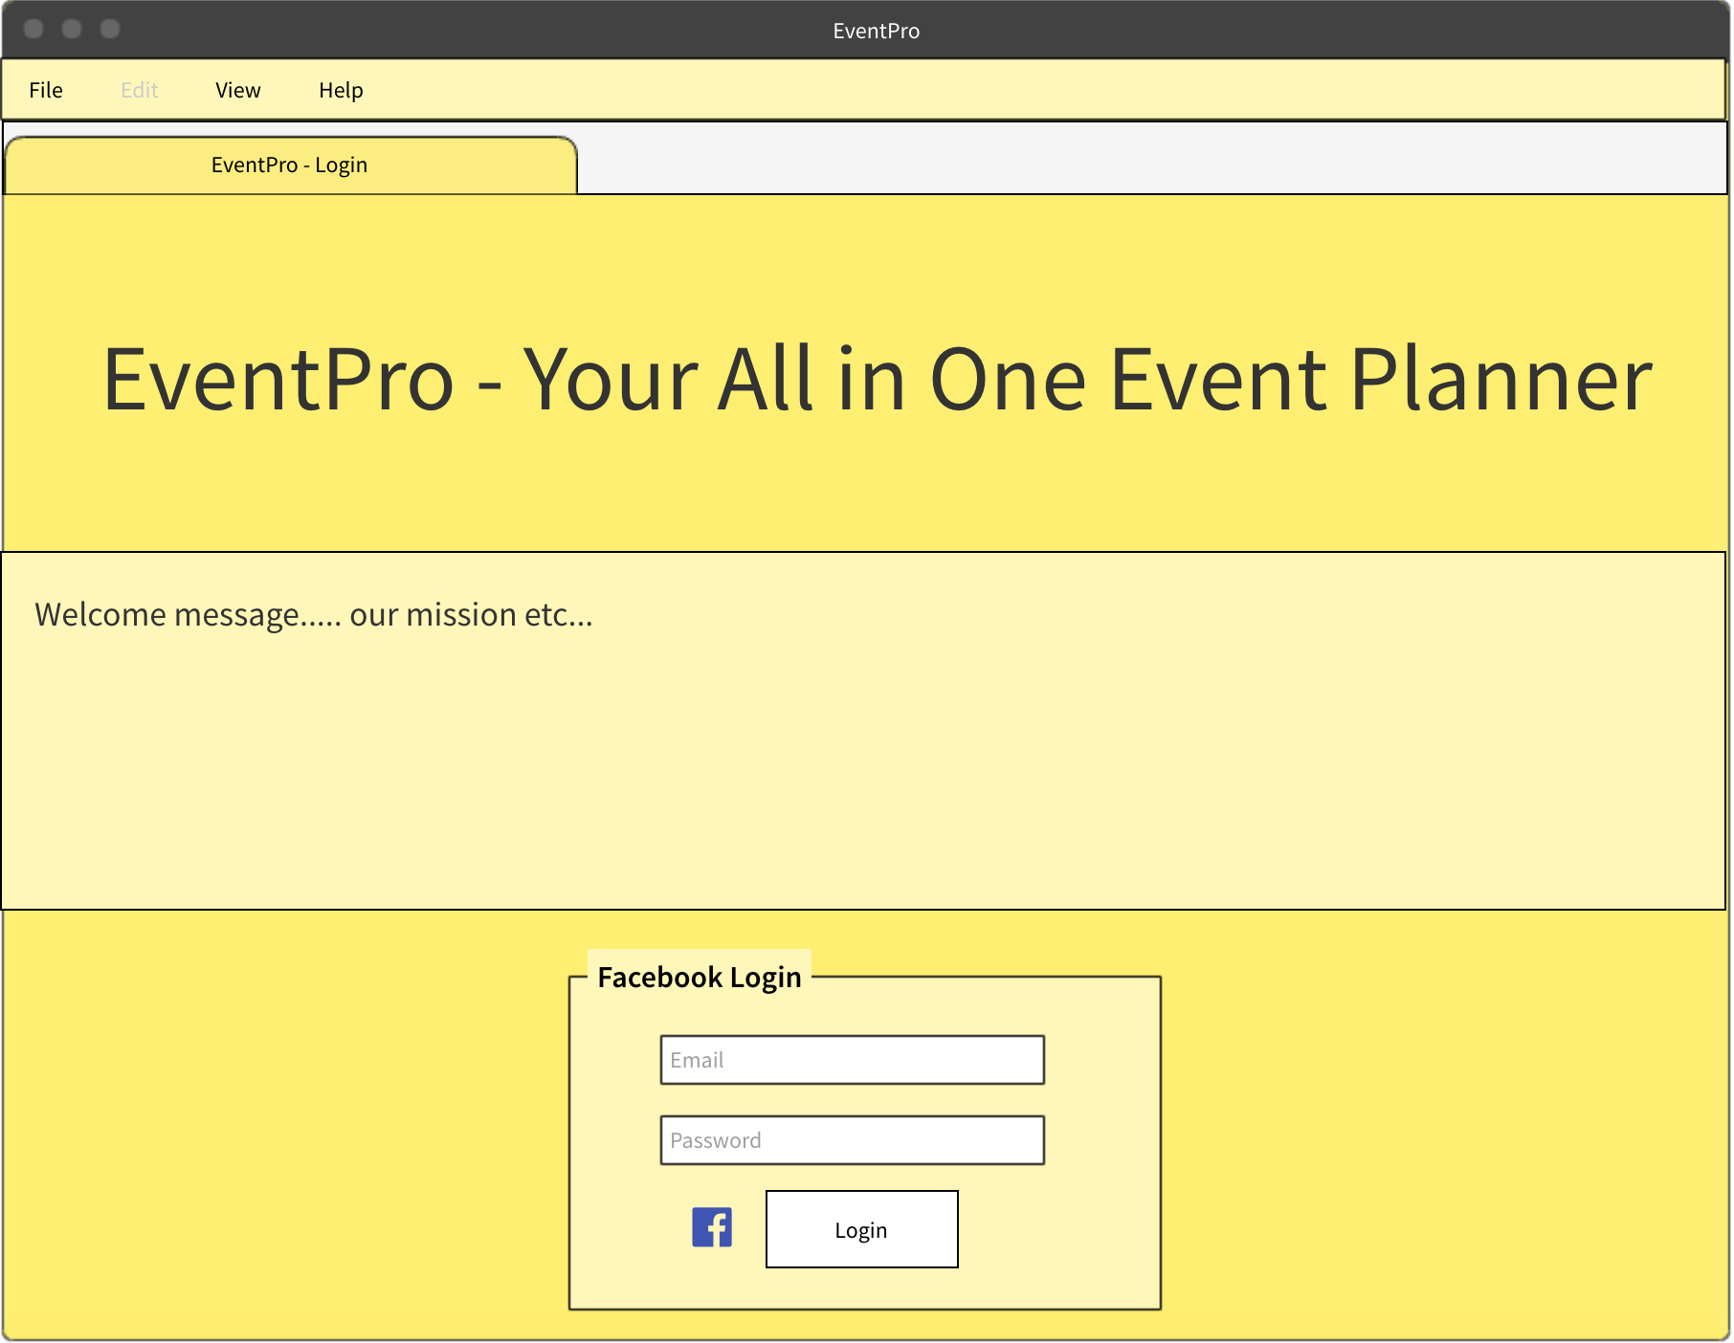

Design 4)

